Configuration to run this project on Eclipse
-----------------------------------------------

- Copy the source code and the input software in a directory
- Download and run eclipse(any version from Indiego)
- Create a project and copy the source code of the project into the eclipse create project.
- Right click on the project and select Run As Configuration:
  - Create new lunch configuration
  - Browse the project for you new created configuration using “Browse” button at the right corner.
  - Browse the main class for the created configuration using “Browse button at the right corner”.

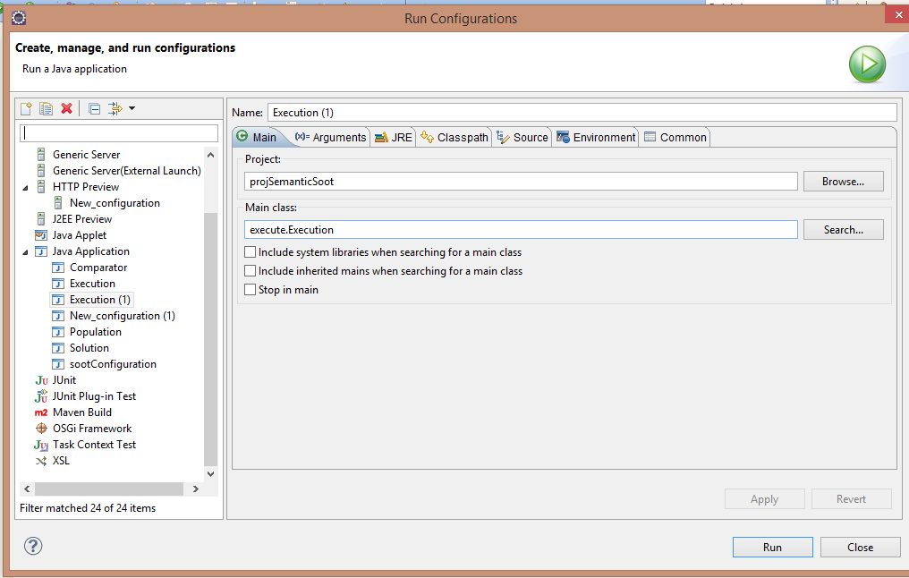

  - Click on Argument and look for label “working directory below your screen”. On working directory, select other and put the correct path to the input source code(source code you want to analyze).

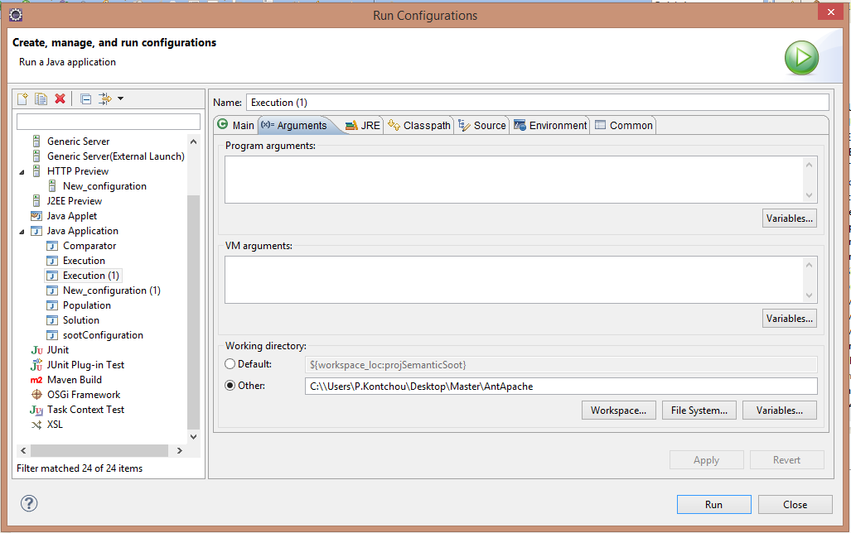

  - Click to Classpath. Under classpath click add External Jar at the left hand side. And browse the Jar file SOOT2.5 from the project directory under library.
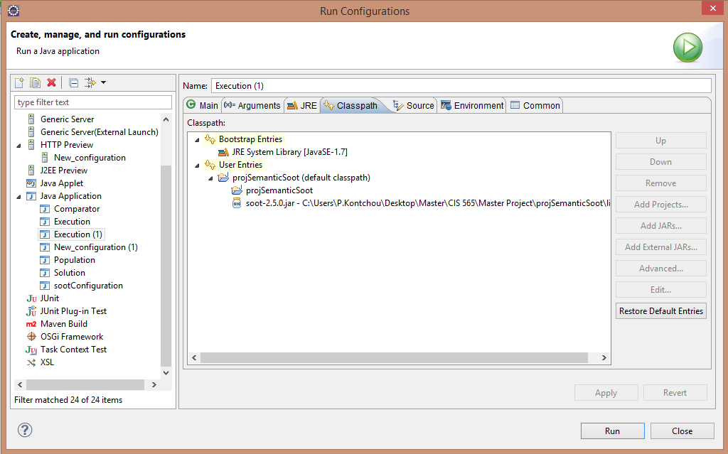

- Go to CGBuilder class and Change the path of all links with the appropriate project with respect to your computer directory.
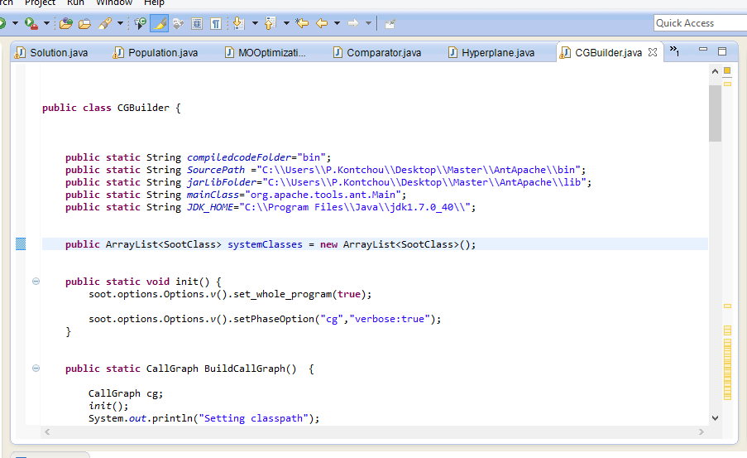

- Go to class population and change the directory with your computer directory where you want to export results. Change the directory on these three functions: export_configuration, export_solution_value, export_pareto.
- Right click on the project and select Run As configuration and click Run.

